Creating a Positive Classroom

Leslie Allen – Secondary PBIS Coach/PEAKS New Teacher Team
Leslie.allen@canyonsdistrict.org

Allan Whitmore – Elementary PBIS Coach
Allan.whitmore@canyonsdistrict.org

Julie Winfree – PEAKS New Teacher Team
Julie.winfree@canyonsdistrict.org

Task 1: Quick write:

Think of a class/teacher where you had a positive experience. What were some of the characteristics of that classroom?

Establishing Expectations

Task 2: Developing Your Rules

Review the Characteristics of Good Practice Rules with a partner.

Think about your classroom rules. Do you need to make modifications?

Characteristics of Good Proactive Rules
Modified from The Tough Kid Book: Practical Classroom Management Strategies

- Keep the number of rules to a minimum- about five rules for each classroom.
- Have the rules logically represent your basic expectation for a student’s behavior in your classroom.
  - Turn in your work on time
- Keep the wording positive.
  - Walk at all times in the classroom - instead of don’t run.
- Make your rules specific. There may be “loopholes” in poorly stated rules.
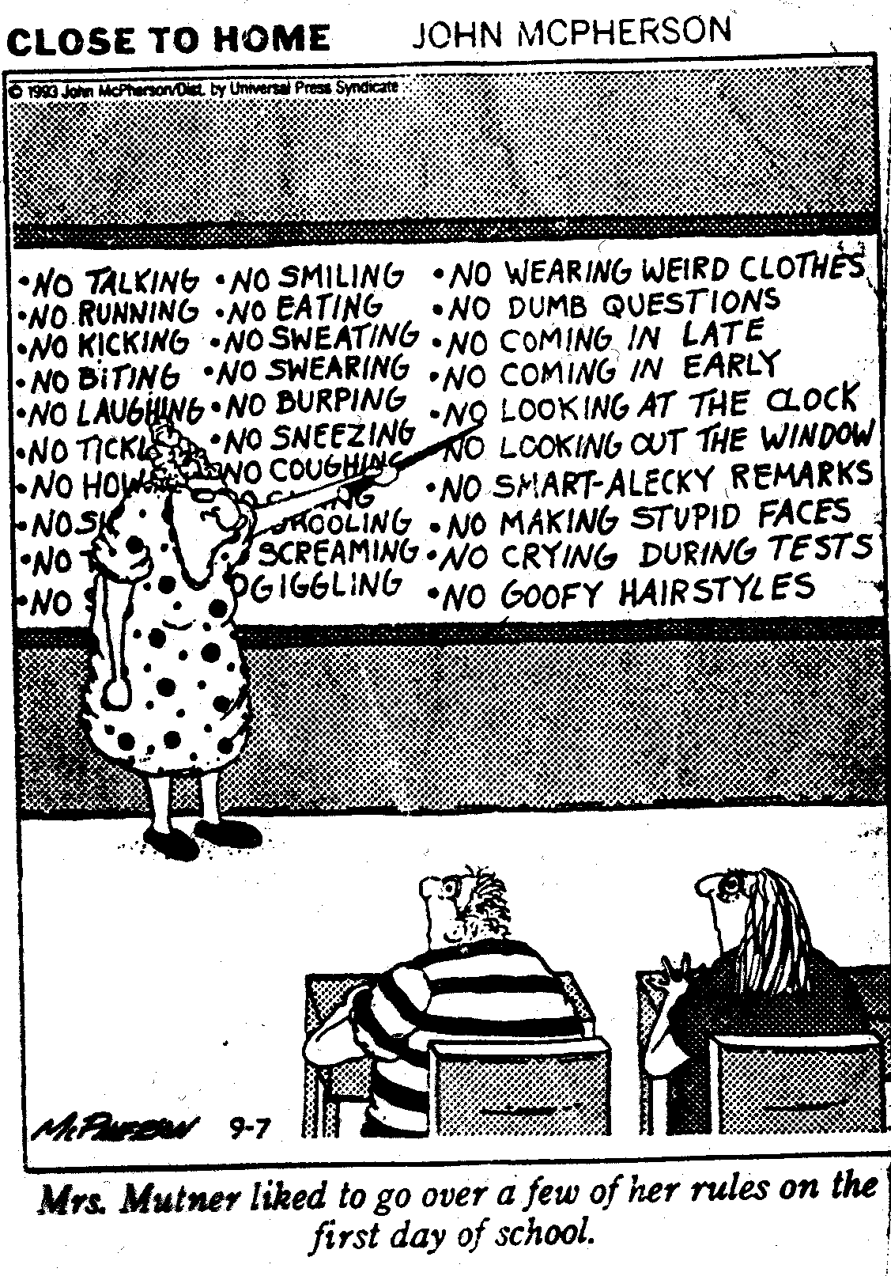
  - Sit in your seat unless you have permission to leave.
- Make your rules describe behavior that is observable and measureable.
  - Raise your hand and wait for permission to speak
- Publicly post the rules in a prominent place in the classroom
- Tie the rules to positive and negative consequences
- Always include a compliance rule.
  - Do what your teacher asks immediately.

Rules, Routines, & Arrangements

Rule: posted & _________________

Routine: ___________________, times, groupings, etc.

Arrangements: physical boundaries, ________________, etc.

Task 3: Predictions
Predictable Failures | Proactive Solutions

Teach Expectations

Teaching Expectations

_____________________ all rules & routines!

Practice, _____________, practice

_________________

Task 4: Article Read: Fred Jones Article

Read through the section titled A Sample Procedure

Underline things you agree with, and circle things you may be unsure about.

Dr. Fred Jones's Tools for Teaching
Rules, Routines, and Standards In Elementary and Secondary Grades

TEACHING ROUTINES SAVE TIME AND EFFORT

A classroom routine is simply a well-rehearsed response to a teacher's directive. The alternative is usually noise, milling around, and time wasting on the part of students, as well as nagging on the part of the teacher.
A classroom routine is, therefore, one of a teacher's primary labor-saving devices. Yet, classroom routines are not free. They are not simply be announced. They must be taught and practiced. Let's take a look at the teaching of a routine in order to get a sense of the effort that goes into getting the class to do as you ask.
A SAMPLE PROCEDURE

Imagine you are a fourth grade teacher and it is the first day of school. Today, you will take the class to the library to meet the librarian. Before the class can get to the library, they must pass through the hall. Before they can do that, however, you must teach the lesson on passing through the halls quietly.

First, we set the stage by talking about how noise in the halls prevents students in other rooms from learning. You know that tune.

Next, before going out into the hall, you must develop visual cues, so you can pantomime instructions to students. A finger to the lips or mimicking zippering the mouth is standard fare. You also will need "stop" and "start" signals. One signal you cannot do without is the signal to "stop, go back, and start all over." You probably remember it: the teacher turns solemnly, holds both palms toward the students, and with a circular motion, points both index fingers back toward the classroom.

When the class is ready to follow your non-verbal cues, you head into the hall. With due seriousness, you check the lines for straightness before giving the signal to "follow me." The little band heads down the hall.
Now, let's interject a note of reality. What do you think the odds are that this collection of fourth graders will make it all the way to the library in complete silence? If your guess is "zero," you show real promise as a teacher.

Halfway down the hall, you hear a giggle from somewhere in the group. Do you care who giggled? No. Do you care how loud it was? No. Do you care whether students in nearby classrooms were actually pulled off task? No.
You turn, hold palms toward the class, make the circular motion with your hands, and point back toward the classroom. Brace yourself for the pained looks on those little faces. Some students show disbelief for a moment before they realize you are not kidding. Keeping a straight face is the hardest part of this routine.
The class shuffles back to where they began and you repeat your non-verbal signals: "straight lines, zippered lips, follow me." Off you go again.
This time, the class makes it two-thirds of the way to the library when you hear talking at the end of the line. Do you care who talked? No. Do you care how loud it was? No.
You turn, hold palms toward the class and give your now well-known "about face" signal. This time you see real pain on the students' faces. Several students mouth the words, "I didn't do it," with pleading hands and looks of exaggerated sincerity. Keep a straight face.
Back to the beginning. "Line straight, lips zipped, follow me." Off they trundle one more time.
This time, they almost make it to the library when you hear whispering behind you. You know what to do by now, don't you? The pain registered on students' faces the third time around is almost too much to bear. Bite your lip.
Old pros know that this is the only way to play the game. Green teachers need to be reassured that they are doing the right thing.
By practicing the routine to mastery, you are signaling to students by your investment of time and energy that this piece of behavior is important. And you are teaching them a thing or two about yourself. They are learning that you are the living embodiment of two timeless characterizations of a teacher: "I say what I mean, and I mean what I say" and "We are going to keep doing this until we get it right."
ESTABLISHING STANDARDS
And now, a note about standards: it is easier to have high standards than to have low standards.

To understand how that works, first you must realize that most of the reinforcement for deviant behavior in the classroom comes from the peer group.

A student makes a silly remark and four kids giggle. The student who made the silly remark was just reinforced by four peers for playing the clown.

How can you turn that around? Nagging won't help. Rather simply practice the routine to mastery! As you practice, practice, practice, a transformation occurs within the peer group.

Let's return to our example of teaching students to walk quietly through the halls. After you stop and start over for the third time, 'the many' start losing patience with trekking up and down the hall. When they get tired of that repeated practice, they also lose patience with 'the few' who are causing them to do it. The next time they move down the hall, when one of the class clowns begins to do something silly, he or she immediately gets "dagger looks" from fellow classmates. Sensing that the behavior is now "uncool" instead of "cool," the goof-off quits the clown routine.

Finally, the class makes it to the library. In the process, students learn that "quiet" means quiet. Only in that way, do they learn to take you and your standards seriously.
TEACHING ROUTINES VERSUS ANNOUNCING RULES
Research has repeatedly shown that highly effective teachers spend most of the first two weeks of a semester teaching classroom routines. They know there is no free lunch. It is a case of
"Pay me now, or pay me later.
Do it right now, or do it all year long."
The older the students, the less investment we make in teaching them routines. Typically, by high school, teaching routines has become rather perfunctory -- often consisting of just a few announcements on the first day of school.
When secondary teachers are asked why they don't spend more time teaching procedures, they reply, "The students should know how to behave by now. Besides, I don't have the time."
Yet, two of the most common complaints about student behavior from secondary teachers is "interrupting one another" and "talking while I'm talking." Both of those behaviors represent primary-grade socialization. The fact that they still occur in high school at a high rate simply demonstrates that students quickly regress when the teaching and enforcement of standards become lax.
Students, of course, know how to behave in class. The question is do they have to? Students adjust their behavior to match the standards of each teacher. The standards in any classroom, to put it bluntly, are defined by whatever any student can get away with.
The necessity of actually teaching students to behave the way you want them to behave often becomes real for secondary teachers when we consider a new piece of behavior rather than behavior that is a holdover from previous years.
Imagine, for example, teaching safety procedures in chemistry class. According to the manual, the procedure for students to follow in the case of a caustic substance being splashed into the eyes is to "irrigate" the eyes with running water as quickly as possible.
Easy to say, but what will happen at the time of crisis? The student with acid in his or her eyes will be out of control, probably screaming and thrashing about. What physical response do you need from the other students?
If it has not been practiced, it will not happen. Chances are it will be a scene reminiscent of life-saving class at the swimming pool; Turn the person around forcefully, get your forearm across the throat, and force his or her head under the faucet face up. If students leave class today with dry collars, chances are they won't be able to help one another when the time comes.
A teacher will say, "But students are supposed to wear safety goggles at all times!" True! But then everyone should drive the speed limit too. If everybody followed the rules, we wouldn't need safety procedures. In fact, students often take off their goggles because they fog over, and then forget to put them back on.
Investing time in the teaching of classroom procedures is a classic example of proactive versus reactive management. As always, prevention is cheaper than remediation. But prevention is not free. You must invest "up front" if you want to reap the dividends for the remainder of the semester.
This article is condensed from Dr. Jones' award winning book Tools for Teaching. Illustrations by Brian Jones for Tools for Teaching.

Reinforce Expectations

Task 5: Reinforcers

Turn to a partner and share a reinforcer that you used during student teaching, or that you experienced as a student in a class. List a few ideas from the group share out.

Success is more likely in the longer term when . ..

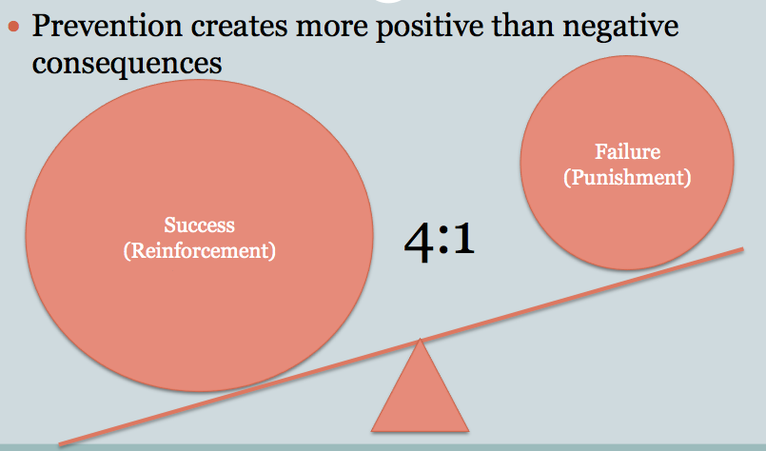

Continuum of Reinforcement

________________________

Nod, wink, etc.

________________________

Public Acknowledgement

________________________

Privileges

________________________

Correct Behaviors

Correct Behaviors

Use low key strategies for small problems:

Re-teach expectations

_________________________

Take away privileges

__________________________

For bigger problems try:

__________________________

Problem Solving

DON’T CHANGE THE RULES, CHANGE THE ROUTINE OR ARRANGMENTS IF PROBLEMS ARISE!

Use resources available to you

